# Celebrating

# Erev Shabbat

**j0300902[1]**

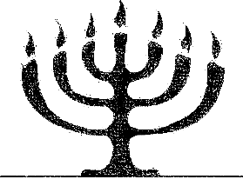**Before Shabbat and guests come:**

***wifely blessing for the shabbat****:*

Blessed are you, Yehovah our God, King of the universe, who has given us new life through Your Son, Yeshua, has sanctified us by Your commandments, and has commanded us to set apart the Shabbat.

May it be Your will, Yehovah, my God and God of my forefathers, that You show favor to me (my husband, my sons, my daughters, my father and my mother) and all my relatives (and our friends gathered here with us); that You grant us and all Israel a good and long life; that You remember us with Your boundless grace and mercy; that You bless us with great blessings; and that You make our households complete; that You cause Your Set-Apart Spirit to dwell among us.

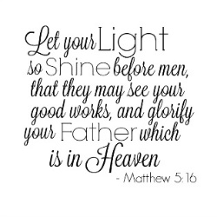Privilege me to raise children and grandchildren who are wise and understanding, who love You, Father Yehovah, and fear You; people of truth, set-apart offspring, committed to You, who illuminate the world with the entirety of your Torah and good deeds and with every labor seek to serve You, our Creator. Please, hear my supplication at this time and cause our light to illuminate this world with Your NAME, and let Your countenance shine so that the whole world may know You. **AMEN**.

***BLESSING THE CHILDREN:***

*a Son:*

May Yehovah make you like Ephraim and Manasseh,

Like Caleb, Joshua, Cornelius and Joseph.

May Yehovah make you like King David and the Apostle Paul,

And like all the godly men of the scriptures

--And especially like Yeshua the Messiah.

*a Daughter:*

May Yehovah make you like Rachel and Leah,

Like Rebecca, Tamar, Tabitha and Priscilla,

May Yehovah make you like Ruth and Queen Esther,

And like all the godly women of the scriptures

--And especially like Yeshua the Messiah.

***BLESSING OF THE WIFE/MOTHER:***

A wife of noble character, who can find?

She is worth far more than rubies.

Her husband has full confidence in her,

and he lacks nothing of value.

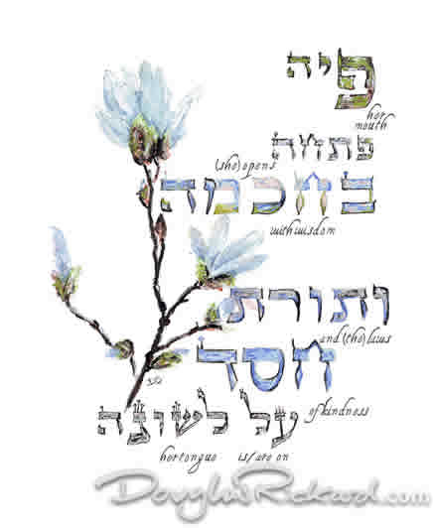She brings him good, not harm

All the days of her life.

She is clothed with strength and dignity;

She can laugh at the days to come.

She speaks with wisdom

And faithful instruction is on her tongue.

She watches over the affairs of her household,

And does not eat the bread of idleness.

Her children arise and call her blessed.

Her husband, also, and he praises her:

“Many women do noble things,

but you surpass them all!”

Charm is deceptive, and beauty is fleeting;

But a woman who fears YHVH is to be praised! **(Proverbs 31)**

***BLESSING OF THE HUSBAND/FATHER:***

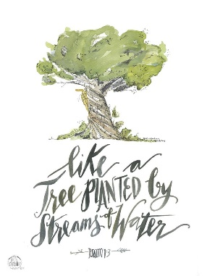

Blessed is the man

who does not walk in the counsel of the ungodly,

nor stands in the way of sinners,

nor sits in the seat of the mockers.

But his delight is in the Torah of Yehovah,

and upon this Torah he meditates day and night.

And he shall be like a tree, planted by streams of water,

which brings forth its fruit in its season,

whose leaf does not wither,

and whatever he does prospers.

For Yehovah knows the way of the righteous:   
but the way of the ungodly shall perish. **(Psalm 1)**

**at start of Shabbat (with guests):**

יְבָרֶכְךָ יְהוָה וְיִשְׁמְרֶֽךָ׃

יָאֵר יְהוָה פָּנָיו אֵלֶיךָ וִֽיחֻנֶּֽךָּ׃

יִשָּׂא יְהוָה פָּנָיו אֵלֶיךָ וְיָשֵׂם לְךָ שָׁלֹֽום׃

***Husband says:***

Y’varekh’kha יְחוָח v’yishm’rekha.

Yaer יְחוָח panav eleykha vichunnekha.

Yissa יְחוָח panav eleykha v’yasem l’kha shalom.

May יְחוָח bless you and keep you.

May יְחוָח make His face shine upon you

and be gracious to you.

May יְחוָח turn his face toward you and give you peace.

***I Love You, Yah***

I love you, Yah, and I lift my voice,

To worship you; Oh, my soul, rejoice.

Take joy, my King, in what you hear,

May it be a sweet, sweet sound in your ear.

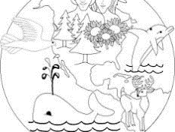***(You can repeat a second time – parts are encouraged.)***

***KIDDUSH:***

*(Setting apart, or making holy, the Shabbat)*

*“Thus the heavens and the earth were completed in all their vast array. By the seventh day God had finished the work he had been doing; so on the seventh day he rested from all his work. And God blessed the seventh day and set it apart. He made it special because on that day he rested from all the work he did while creating the world.”* **(Genesis 2:1-3)**

*“You must* ***REMEMBER***[1] *to keep the Sabbath a special day. You may work six days a week to do your job. But the seventh day is a day of rest in honor of* יְחוָח *your God. So on that day no one should work--not you, your sons and daughters, or your men and women slaves. Even your animals and the foreigners living in your cities must not work! That is because* יְחוָח *worked six days and made the sky, the earth, the sea, and everything in them. And on the seventh day, he rested. In this way* יְחוָח *blessed the Sabbath--the day of rest. He made that a very special day.”*   
**(Exodus 20:8-11)**

*“You must* ***KEEP***[2]*the Sabbath a special day like* יְחוָח *your God commanded.*

*“Work six days a week and do your job, but the seventh day is a day of rest in honor of* יְחוָח *your God. So on that day no one should work--not you, your sons and daughters, foreigners living in your cities or your men and women slaves. Not even your cattle, donkeys, and other animals should do any work! Your slaves should be able to rest just as you do. Don't forget that you were slaves in the land of Egypt.* יְחוָח *your God brought you out of Egypt with his great power and made you free. That is why* יְחוָח *your God commands you to always make the Sabbath a special day.”* **(Deuteronomy 5:12-15)**

*“And the children of Israel shall keep the Sabbath, to make the Sabbath an eternal covenant for their generations. Between Me and the Children of Israel it is a sign forever that in six days* יְחוָח *made heaven and earth, and on the seventh day He rested and was refreshed.”* **(Exodus 31:16-17)**

***This is the Day***

(*Verse 1)* This is the day, *(repeat)*

That Yehovah has made *(repeat)*

We will rejoice *(repeat)*

And be glad in it *(repeat)*

*(Chorus)* This is the day that Yehovah has made

We will rejoice and be glad in it.

This is the day *(repeat)*

That Yehovah has made

*(Verse 2)* This is the Shabbat,

That Yehovah has made… (etc.)

*“The earth is* יְחוָח*'s, and everything in it, the world, and all who live in it; for he founded it upon the seas and established it upon the waters.*

*Who may ascend the hill of* יְחוָח*? Who may stand in his holy place? He who has clean hands and a pure heart, who does not lift up his soul to an idol or swear by what is false.”* **(Psalm 24:3-4)**

***Bless Our Home***

*(tune: Edelweiss)*

Bless our home, bless our food;

Come, O Lord, and sit with us;

May our talk glow with peace,

May Your love surround us;

Friendship and love, may they bloom and grow,

Bloom and grow forever;

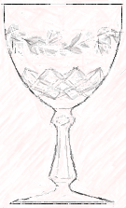Bless our home, bless our food;

Come, O Lord, and sit with us.

***BLESSING THE CUP:***

*All take the cup in the right hand as the husband recites:*

Blessed are You, יְחוָח, our God, King of the universe, who brings forth the fruit of the vine and gives us the true vine, Your son, Yeshua that grafts us in as branches because of the blood which He shed for us.

Blessed are You, יְחוָח, our God, King of the universe, who has set us apart with His commandments, took pleasure in us, and with love and favor gave us His holy Sabbath as a heritage, a remembrance of creation. For You chose us and You set us apart from all the nations through your Son. And Your holy Sabbath You gave us with love and favor as a heritage.   
Blessed are You, יְחוָח, who sets apart the Sabbath.

*“What shall I render to YHVH for all his benefits to me?   
I will lift up the cup of salvation and call on the name of YHVH."* **(Psalm 116:12-13)**

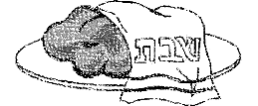

*All say:* **AMEN.**

*All take a drink from their cups.*

***BLESSING THE BREAD:***

*Husband then takes the bread, lifts it up, and recites:*

Even as this bread sustains life, let us remember the Bread of Life, who was buried *(uncover the bread)* and who rose again.

Blessed are You, יְחוָח, our God, King of the universe, who brings forth bread from the earth, and gave us Your Son, who was broken and crucified, who was buried in the earth, and came out from the earth to give us eternal life, the first fruits of the resurrection.

*“But he was wounded for our transgressions; he was crushed for our iniquities; upon him was the chastisement that brought us peace, and with his stripes we are healed*.” (**Isaiah 53:5)**

*“I am the living bread which came down from heaven. If anyone eats of this bread, he will live forever; and the bread that I shall give is My flesh, which I shall give for the life of the world."* **(John 6:51)**

*All say:* **AMEN.**

*Husband breaks off a piece and passes it around the table. Each person breaks off a piece until all have partaken.*

*The wife says:* **Let the celebration begin!** *(Dinner is served.)*

1. ***zaw-kar***—make mention of, recount, be mindful of
2. ***shaw-mar***—observe, protect, preserve, guard